Design Steps of PMSM
The flow diagram representing the design steps of the PMSM is given in Fig. 2. As given in the flow diagram, design steps are discussed in the following section after PMSM parameters are determined according to the application area. The stator, rotor and slot dimensions, electromagnetic electrical equations are calculated together. When the motor is reached to desired performance, this operation is terminated, otherwise the designing calculations will repeat again. The flow diagram in Fig.2 is explained in detail in the following sections.
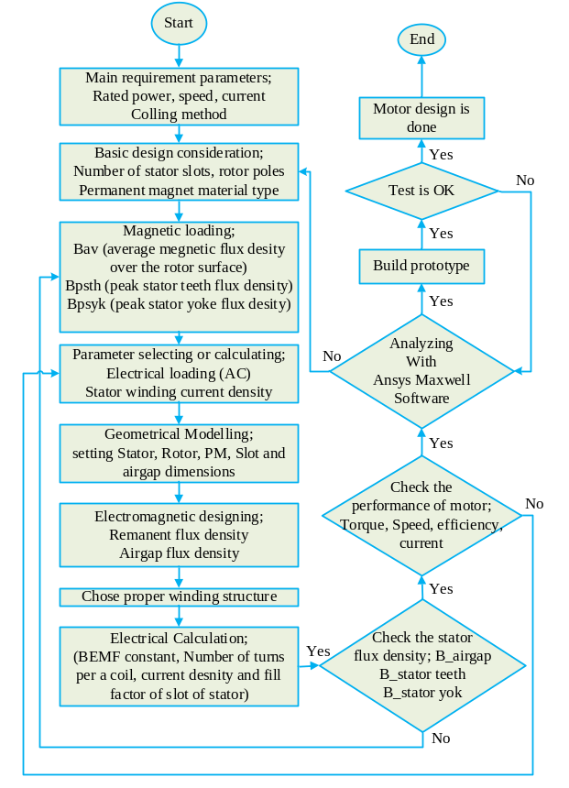
Fig .2. Flow chart for design procedure

Parameters Detecions
Rated values are determined according to the place and application where the motor will be used. This is usually updated according to customer requirements. The following general table is verified according to customer requirements.
According to special requirements, extra dimensional limitations can be included in Table.1 or removed completely.
To design the motor for the rated values, the geometry design, electromagnetic and electrical calculations will be done. During designing the geometrical calculations, the motor usage location limitations must be considered by designer and they are: axial length and stator outside diameter as shown in Table.1.
TABLE. 1. MOTOR RATED VALUES
A_{bb} | Parameter | Value | Unit
P_{out} | Power | 77 | Nm
N_{rpm} | Speed | 3400 | rpm
I_{r} | Current | 0.5 | A
L_{stk} | Axial length | 18 | mm
D_{so} | Stator outside diameter | 90.35 | mm

Parameters selecting and/ or calculating

Electrical machine design usually starts from the famous sizing equation [10,11], as shown in (1).
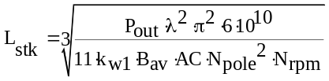 (1)
Where P_{out} is the motor rating power in watt (W), B_{av} is the specific magnetic loading in Tesla (T), AC is the
specific electrical loading in ampere per meter (A/m), D_{si} is the stator bore diameter in millimeter (mm), L_{stk} is the axial length in millimeter (mm), K_{w1} is maximum fundamental winding factor, and N_{rpm} is the rated speed in revolution per minute (rpm) [14] [15]. Values for B_{av} and AC are selected by the designer at the start of the design process.
The electric loading AC is defined as the linear current density around the airgap circumference, that is, the number of ampere-conductors per meter around the stator surface that faces the airgap is calculated as [12];
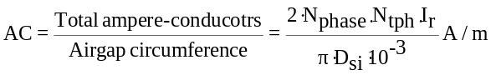 (2)
Where I_{r} is the RMS phase current, N_{phase} is the number of phases, N_{tph} is the number of turns in series per phase.
The specific electric loading AC is generally limited (8000-45,000 A/m) by the copper loss in the conductors, the effectiveness of the cooling strategy, the temperature limitation of the insulation material, the load profile, and the duty cycle. In the traditional design, the selection of B_{av} and AC are primarily based on the designer’s experience. Some textbooks provide guides from previous design experiences [14] [15].
The magnetic loading B_{av} is defined as the average flux-density over rotor surface. The magnetic loading B_{av} is limited (0.40-0.7 T) by the saturation point of the materials used, the hysteresis losses and eddy current losses, the stray losses, the effectiveness of the cooling strategy, the load profile, and the duty cycle [14] [15].
In AC motors the flux is calculated by (3), and is distributed sinusoidal in airgap as shown in the analysis graphic is given in Fig.5. [12];

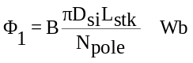 (3)

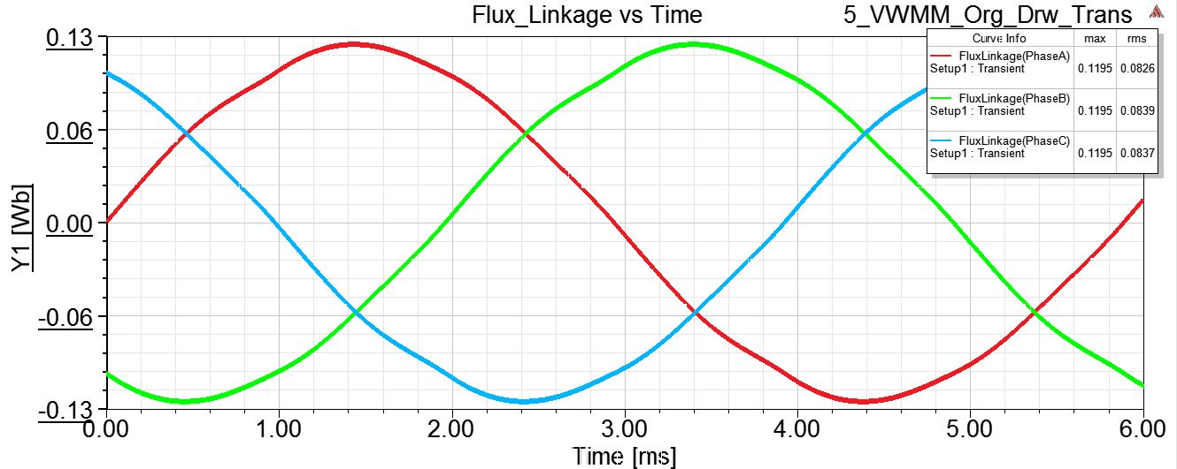
Fig. 3. Flux linkage of graphics of the three phase

Fundamental winding factor (k_{w1}) is calculated by (4), for some standard motors a table of maximum fundamental winding factor is given as shown in Table.2;
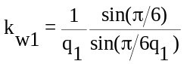 (4)
q₁ is number of slots per pole phase;
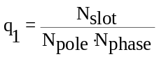 (5)

TABLE 2. OF MAXIMUM FUNDAMENTAL WINDING FACTOR FOR SOME STANDARD MOTORS
 |  |  | 2 | 4 | 6 | 8 | 10 | 12 | 14
 |  | 3 | 0.9 | 0.9 |  | 0.9 | 0.9 |  | 0.9
 | Integer-slot winding | 6 | 1 | 0.9 |  | 0.9 | 0.5 |  | 0.5
 | Fractiona-slot winding | 9 | 0.9 | 0.6 | 0.9 | 0.9 | 0.9 | 0.9 | 0.6
 | Concentrated winding | 12 | 1 | 1 |  | 0.9 | 1 |  | 1
 | Unbalanced winding | 15 | 1 | 1 |  | 0.7 | 0.9 |  | 1
 |  | 18 | 1 | 0.9 | 1 | 0.6 | 0.7 | 0.9 | 0.9
 |  | 21 | 1 | 1 |  | 0.5 | 0.7 |  | 0.9

Where N_{slot} is number of slots, N_{pole} is number of poles and N_{phase} is number of phases. After B_{av} and AC are selected, the L_{stk} value of the machine is then calculated by (1). In this paper to design a motor with minimum cost according the Table.3 the aspect ratio value is selected 1.7 [28].

TABLE 3. ASPECT RATIO WITH DESCRIPTIONS
No | Aspect ratio | Description
1 | 1.5-2 | Minimum cost
2 | 1.5 | High efficiency
3 | 1.0-1.5 | Best power factor
4 | 1.0 | Equivalent design

To go further to designing PMSM, the current density values is also important parameter. This parameter directly affects the operation temperature of the stator winding. The current density is typically selected by the designer’s experience or can be chosen according the motor cooling types, as calculated according to certain empirical rules, the current density is generally selected in the range of (3 to 7 A/mm2) [14] [15] [17].
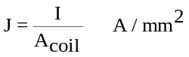 (6)
Where A_{coil} is stator coil area per a slot.
After considering the necessary limitations, the specified basic dimension parameters of the motor between (1) and (6) are determined as in Table 3

Table.4- Motor geometrical dimensions
No | Parameter | Value | Unit
1 | J | 8.04 | A/mm²
2 | AC | 22637 | A/m
3 | B_{av} | 0.40 | T
4 |  | 1.7 | -
5 | q₁ | 0.5 | -
6 | K_{w1} | 0.866 | -

Stator Dimensions
After calculating axial stack length by using the (1) whole the stator dimensions can be determined step by step by geometrical calculation.
Using calculated L_{stk} and selecting aspect ratio parameters with (7) the stator inside diameter can be determined as;
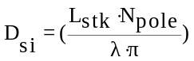 mm (7)
Rotor outside diameter can be calculated by eliminating the air gap from stator inside diameter
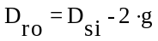mm (8)
The rotor inside diameter can be designed according the usage of the motor and mechanical design.
The tooth pitch is directly proportional with the tooth width as given in (9), is clarified as shown in Fig.4 [12].
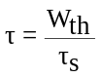 (9)
According the designer experience the stator tooth width is usually equal to half of tooth pitch (Slot pitch) so;
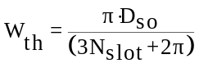 (10)
The stator yoke length can be equal with the stator tooth length as;
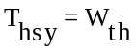 (11)
With the equations (8-11) approximately whole the dimensions of stator except the stator dimensions are calculated. The slot dimensions are discussed in next sections.
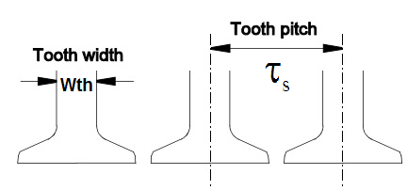
Fig.4. The tooth width and tooth pitch

Stator Slot Dimensions
PMSMs are usually composed three types of materials they are: rotor and stator steel, PMs and stator coil winding, these materials dimensions and properties are so important.
In designing process. As shown in Fig.5 to model geometrical dimensions, some proved assumptions could be used to design the stator slots [13].

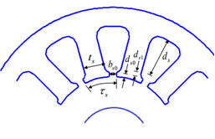
Fig.5. Geometrical dimensions of stator slot

Equation (12) explains each slot pitch, this is obtained, dividing the stator circumference by number of slots.
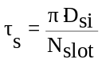 (12)
D_{si,} stator inside diameter; N_{slot,} number of stator slots in motor geometrical model. By using slot pitch parameter, as seen in (12) the stator tooth width can be easily determined.
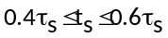 (13)
After determining the stator tooth, by (14) stator slot height is designed.
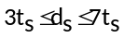 (14)
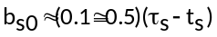 (15)
b_{so}, slot opening length is calculated as follow.
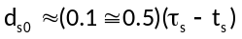 (16)
d_{so}, this parameter shows the tooth opening depth.
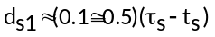 (17)
d_{s1}, is stator slot bottom radius.
Based on the determined basic motor parameters, stator slot parameters were calculated as in Table 4.

TABLE 4. DIMENSIONS OF STATOR SLOTS
Dimensions | Values (mm)
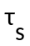 | 22.50
 | 7.50
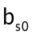 | 3.75
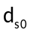 | 0.95
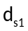 | 0.25

Proper winding Schematic
There are two types of winding for PMSM, they are concentrated and distributed winding. They are also classified into two class as, double layer or single layer. Type of winding for each motor is determined according the number of poles, slots and phases. If the ratio, number of slots per pole per phase (q₁), is greater or equal to one, distributed winding will be preferred in other case concentrated winding will be preferred.

Electrical calculation
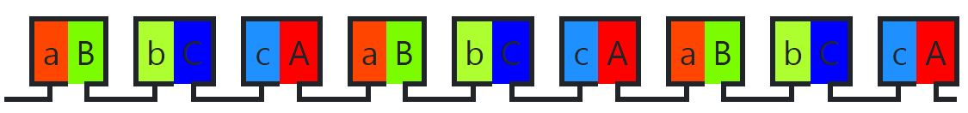
Fig.6. preferred winding schematic
Other more important parameter to discuss is open circuit test. By test the back electro-motive force (BEMF) maximum induced voltage in rated speed will be known. This value must be smaller than the bar voltage, otherwise the driver of this motor will be so complex because of field weakening strategy, it is undesired case. Therefore, during specifying the number of turn per a coil the designer should be more consider on this parameter. As calculated in (18) the number of turns per a coil directly proportional to BEMF.
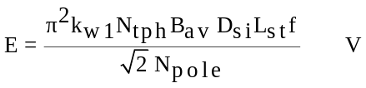 (18)
Where f is the fundamental frequency, and the product k_{w1.}N_{tph} is the effective number of turns in series per phase.

The number of turn per a coil is calculated by (19) or (20).
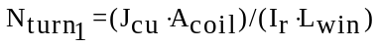 (19)
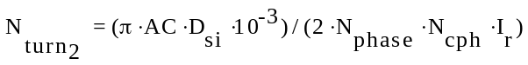 (20)
The current is calculated as follow;
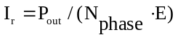 (21)
A_{coil} is calculate;
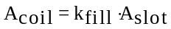 (22)
N_{cph} is coil per phase is calculated as;
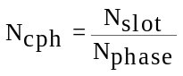 (23)
PMs locations are usually different regards the driver and motor‘s usage duty, PMs directly determine air gap flux curve. To run motors with square current waveform, the PMs must be surface mounted and to run with sine wave it can be inset, buried and surface mounted [16]. Stator winding is another magnetic flux source; it is also one more important factor to determine the air gap flux curve. To run the motor with square current waveform concentrated winding are preferred to get the BEMF in square waveform [16]. It is another critical topic to understand, which motor run with sine wave and square wave. After the number of turns are determined the BEMF is in square wave it means the designed motor should be run by square current waveform as BLDC motor. If the BEMF is in sine waveform the motor should be run as BLAC motor with sine current waveform [16].

References

- M.J. Soleimani Keshayeh, S. Asghar Gholamian. (2013) Optimum Design of a Three-Phase Permanent Magnet Synchronous Motor for industrial applications, International Journal of Applied Operational Research, vol. 2, pp. 67-86.
- Philip Larsson and Niclas Rasmussen, Design, Control and Evaluation of a Prototype Three Phase Inverter in a BLDC Drive System for an Ultra-Light Electric Vehicle, Gothenburg: Chalmers University of Technology, 2013.
- Alexander Kalimov and Sergey Shimansky, "Optimal Design of the Synchronous Motor With the Permanent Magnets on the Rotor Surface," in IEEE TRANSACTIONS ON MAGNETICS, Petersburg, 2015.
- H. Nory, Fırçasız Doğru Akım Motorun Tasarımı ve Denetimi, Elazığ: Fırat University, 2018.
- Ansys, user’s guide – Maxwell 2D, ANSYS Inc., 2012.
- T. Miller, Speed's Electric Machines, 2014.
- Permanent Magnet Synchronous Motor (PMSM) Introduction, University of Central Florida.
- D. D. Hanselman, Brushless Permanent Magnet Motor Design, Orono: University of Maine, 2003.
- İ. Şahin, MEASUREMENT OF BRUSHLESS DC MOTOR CHARACTERISTICS AND PARAMETERS AND BRUSHLESS DC MOTOR DESIGN, Ankara: Middle East University, 2010.
- J. R. HENDERSHOT & T. J. MILLER, DESIGN OF BRUSHLESS PERMANENT-MAGNET MACHINE, Florida: Magna Physics Publishing & Oxford University Press, 2010.
- "https://www.emetor.com/," [Online].
- Y. Duan, METHOD FOR DESIGN AND OPTIMIZATION OF SURFACE MOUNT PERMANENT MAGNET MACHINES AND INDUCTION MACHINES, Georgia: Georgia Institute of Technology, 2010.
- (Oktay AKMAN, Abdullah ÜRKMEZ, "asenkron motor tasariminin bilgisayar programi ile gerçekleştirilmesi")

